Name: ___________________________ Date: ______
Solubility Curves
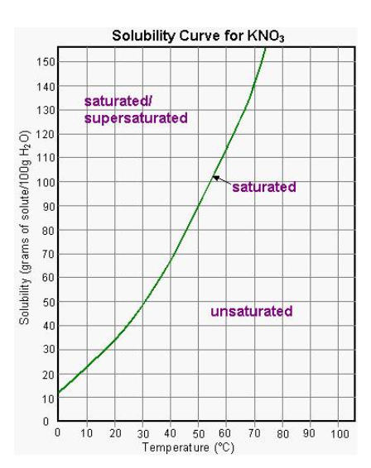
1. How much KNO₃ can be dissolved at 40º C ?

2. At what temperature can you dissolve 70 grams of KNO₃ ?

3. What kind of solution is 80 grams of KNO₃ at 50º C ?

4. What kind of solution is 60 grams of KNO₃ at 60º C ?

5. What kind of solution is 40 grams of KNO₃ at 10º C ?

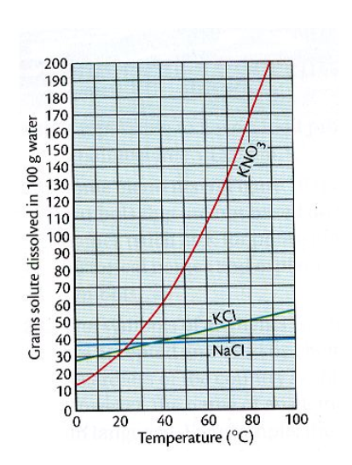
1. How much KCl can be dissolved at 40º C ?

2. At what temperature can you dissolve 40 grams of KNO₃ ?

3. What kind of solution is 80 grams of NaCl at 50º C ?

4. What kind of solution is 60 grams of KNO₃ at 60º C ?

5. What kind of solution is 40 grams of KCl at 45º C ?

6. At what temperature can you dissolve 40 grams of NaCl?

Table G: Solubility Curve Questions
1) What much solute can be dissolved of KNO₃ at 70°C ?
2) At what temperature is water saturated with 15 grams of NH₃?
3) Which of the three substances (NaCl, KNO_{3,} NH₄Cl ) is most soluble in water at 15°C?
4) Is 50g of KCl at 80°C saturated, unsaturated or supersaturated?
5) How much KNO₃ can be dissolved in 100 g of water at 25ºC?
6) How much KNO₃ can be dissolved in 50 g of water at 30ºC?
7) How many grams of NaNO₃ will precipitate (fall) out of a 100ml solution when a saturated solution at 45⁰C is cooled to 10⁰C?
8) Given a 100ml solution containing 10 grams of NaCl at 90ºC, how many more grams of NaCl are required to reach saturation?

