Name: ______________________________________ Date: _________________
Chem R Pd. ____ Table G Practice

Determine the type of solution (unsaturated, saturated, supersaturated) produced.

1) 10 g of NH₃ dissolved in 100 g of water at 90⁰C _______________
2) 30 g of NH₄Cl dissolved in 100 g of water at 40⁰C _______________
3) 105 g of KNO₃ dissolved in 100 g of water at 50⁰C _______________
4) 5 g of NaCl dissolved in 100 g of water at 0⁰C _______________
5) 51 g of KCl dissolved in 100 g of water at 80⁰C _______________

Ex 1) How much HCl should be dissolved in 100 g of water to make a saturated solution at 30⁰C?

Ex 2) How much HCl should be dissolved in 50 g of water to make a saturated solution at 30⁰C?

Ex 3) How much HCl should be dissolved in 200 g of water to make a saturated solution at 30⁰C?

1) How much KClO₃ should be dissolved in 50 g of water at 40⁰C to make a saturated solution? ________

2) How much NaCl should be dissolved in 200 g of water at 90⁰C to make a saturated solution? ________

3) How much KNO₃ should be dissolved in 50 g of water at 60⁰C to make a saturated solution? ________

4) How much KCl should be dissolved in 200 g of water at 50⁰C to make a saturated solution? ________

Ex 1) A solution of NaNO₃ at 30⁰C is saturated. How much salt will precipitate out if the solution is cooled to 10⁰C?

Ex 2) A solution of KI at 20⁰C is saturated. How much salt will precipitate out if the solution is cooled to 10⁰C?

1) A solution of NaCl at 90⁰C is saturated. How much salt will precipitate out if the solution is cooled to 0⁰C?

2) A solution of NaNO₃ at 50⁰C is saturated. How much salt will precipitate out if the solution is cooled to 30⁰C?

3) A solution of KClO₃ at 80⁰C is saturated. How much salt will precipitate out if the solution is cooled to 30⁰C?

4) A solution of NH₄Cl at 10⁰C is saturated. How much salt will precipitate out if the solution is cooled to 0⁰C?

Ex 1) If 100 g of KI are dissolved in 100 g of water at 20⁰C, how much more KI would need to be added to make a saturated solution?

Ex 2) If 20 g of NaCl are dissolved in 100 g of water at 100⁰C, how much more NaCl would need to be added to make a saturated solution?

1) If 5 g of SO₂ are dissolved in 100 g of water at 10⁰C, how much more SO₂ would need to be added to make a saturated solution?

2) If 30 g of NH₄Cl are dissolved in 100 g of water at 80⁰C, how much more NH₄Cl would need to be added to make a saturated solution?

3) If 80 g of KNO₃ are dissolved in 100 g of water at 60⁰C, how much more KNO₃ would need to be added to make a saturated solution?

4) If 20 g of HCl are dissolved in 100 g of water at 90⁰C, how much more HCl would need to be added to make a saturated solution?

General Understanding of Table G Questions

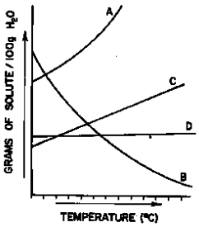
1) The graph below represents four solubility curves. Which curve best represents the solubility of a gas in water?

(1) A (3) C
(2) B (4) D

2) Which salt has the greatest change in solubility between 30⁰C and 50⁰C?
(1) KNO₃ (2) KCl (3) NaNO₃ (4) NaCl

3) Based on Reference Table G, which of the following substances is most soluble at 50⁰C?
(1) KClO₃ (2) NH₃ (3) NaCl (4) NH₄Cl

4) According to Reference Table G, which of the following substances is least soluble in 100 grams of water at 50⁰C?
(1) NaCl (2) KCl (3) NH₄Cl (4) HCl

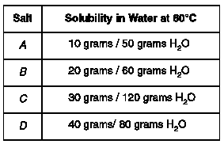
5) Solubility data for four different salts in water at 60⁰C are shown in the table below. Which salt is most soluble at 60⁰C?

(1) A (2) B (3) C (4) D

