Why is the history of the atom so important?

It is fundamental to the understanding of science that science is a process of trial and improvement and represents the best known at the time, not an unerring oracle of truth. Development of an idea and refinement through testing is shown more in the understanding of atomic structure.

John Dalton (1803)

Modern atomic theory (what people think the atom looks like) was born with Dalton when he published his work in 1803. Dalton was the first scientist to propose that matter is composed of tiny particles called atoms. Actually, I’m lying! He really stole this idea from an ancient Greek theorist named Democritus. There was no evidence or proof of atoms back in 460 BC, so people just thought Democritus was crazy and he wasn’t recognized for his theory. With all of the advancements made in science over time, Dalton was able to propose the following theory about atoms and people believed him. Some of the points in Dalton’s theory still stand today, however some we now know to be untrue.

- Atoms are solid spheres that are neutral and indivisible (not able to be broken into smaller particles).
- Atoms of different elements have different weights.
- Atoms of different elements can combine to form chemical compounds.
- Atoms cannot be created nor destroyed in a chemical reaction (conservation of mass).

J.J. Thomson (1889)

Prior to the work of British physicist J.J. Thomson in 1889, scientists believed that atoms were simply solid spheres with no internal structure. Thomson conducted a number of experiments using cathode rays (beams of radiation produced by atoms that travel from one piece of metal to another inside of a glass tube) and proposed the idea that atoms are actually made up of smaller particles.

Thomson discovered that cathode rays travel in straight lines except when they are bent by electric or magnetic fields. Because the cathode rays bent away (were repelled) from a negatively charged plate, Thomson concluded that these rays are made of negatively charged particles. Thomson then measured the mass of cathode rays, showing they were made of particles that were around 1800 times lighter than the lightest atom, hydrogen. Therefore, the particles were not atoms, but a new particle, the first subatomic particle to be discovered.

Soon after this discovery, Thomson began speculating on the nature of the atom. He knew that atoms had an overall neutral charge, so if these subatomic particles within atoms are negatively charged, the atom must contain a positive counterpart. Thomson suggested the “Plum Pudding Model” (yum!!) to describe an atom. A modern illustration of this idea would be a chocolate chip cookie, with the chips representing negatively charged particles and the dough representing positively charged sphere that they are in.

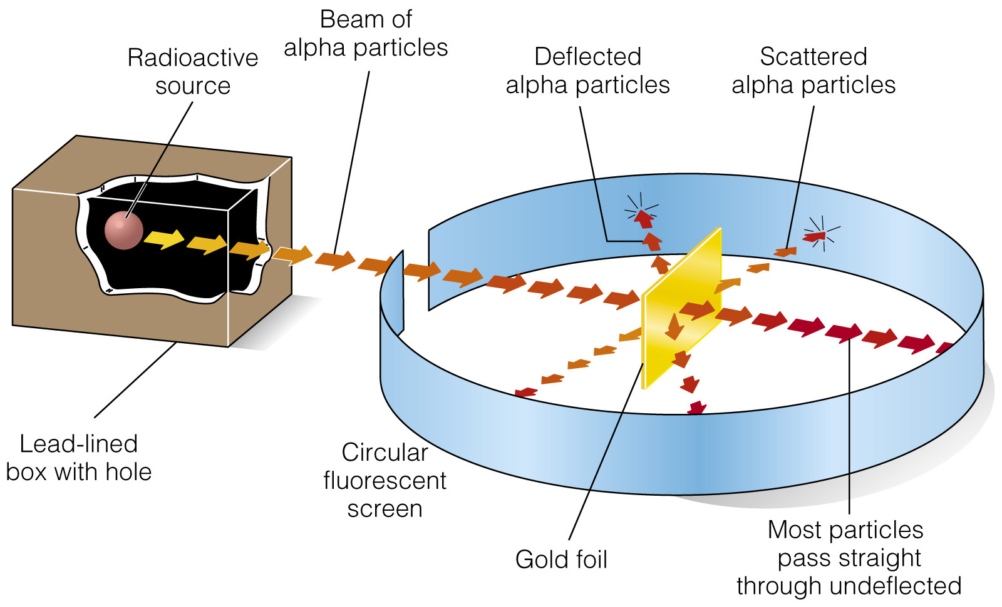
Rutherford (1911)
Ernest Rutherford conducted the famous Gold Foil Experiment in 1911 which disproved the plum pudding model. Alpha particles, which are positively charged, were fired at the gold atoms located in a very thin layer of gold foil. Rutherford made observations regarding if and how the alpha particles passed through the sheet of gold foil. Look at the diagram to the right. Did all of the alpha particles pass through the foil? What could the inside of the atom look like if some passed through and some bounced back? What could the particles be hitting inside of the atom to make them bounce back (repel)?

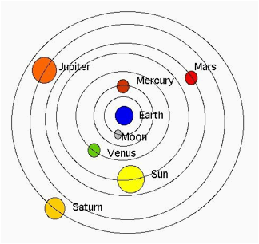
Niels Bohr (1913)
In 1913, Niels Bohr proposed some changes regarding the structure of an atom based off of observations and calculations made from studying the spectral lines (light) produced by a hydrogen atom. When atoms absorb (gain) energy, electrons move away from the nucleus. When they come back towards the nucleus, they release (get rid of) energy in the form of light. He made some assumptions about the internal structure of the atom that built upon Rutherford’s theory based on the light produced.
The Bohr model is also known as the “planetary model” due to the fact that the placement of subatomic particles resembles the planets of our solar system orbiting the sun at very specific distances.

Wave Mechanical Model (Electron Cloud Model)
The current atomic model is a result of work done from the 1920’s to the present by multiple scientists. We now know of a third subatomic particle discovered by a scientist by the name of Chadwick. These particles are also found in the nucleus and contribute to the mass of an atom, but have no charge.
Other ideas were suggested based on the research of multiple scientists regarding the behavior of the electron. Modern physics tells us that the movement of atoms and molecules, including subatomic particles like electrons, cannot be described by the classical laws of physics. Quantum physics was discovered to describe how these tiny things behave. The Uncertainty Principle, discovered by Heisenberg, states that you cannot measure how fast a particle is moving and exactly where it is located simultaneously, with great accuracy. This means that the path of any particle, like an electron, can never be predicted exactly! All quantum physics can do is provide you with probabilities for the location of an electron revolving around an atom (meaning we can determine the general area that the electron is most likely in, but not its exact location). The electron cloud model emerged out of a mathematical equation written by German scientist Schrodinger. The Schrodinger model predicts clouds of probability around the atom where electrons can be found, which we now call orbitals.

