Name: __________________________________ Date: ______________
Chem R Pd. ___ Heat Calculations

MIXED Heat Calculation Problems
Key words to look for:
Q = mc∆T Q = mH_{f} Q = mH_{v}

Problem: | Formula/work: | Answer:
1. How much heat is absorbed when 50.0 g of water is boiled at 100°C?
2. How much heat is absorbed when the temperature of 25.0 g of water increases from 35.0°C to 55.0°C?
3. How much heat is required to melt 45.0 g of ice at 0°C?

4. How many grams of water will 50,000 Joules of heat boil at 100°C?
5. If a 30.0 g sample of water absorbs 400.0 Joules of heat at an initial temperature of 20.0°C, what is the change in temperature?
6. How many grams of water will 800.0 J of heat energy change from solid to liquid?

7. If a 45.0 g sample of water releases 300.0 J of heat at an initial temperature of 40.0°C, what is the final temperature?

Base your answers to questions 8–10 on the information below.

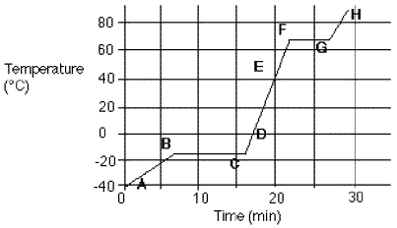
Heating Curve for Mercury
Physical Constants for Mercury
Heat of Fusion (J/g) | 11.
Heat of Vaporization (J/g) | 272
Specific Heat (J/g°C) | 0.14

8. How much heat is absorbed by 50.0 grams of mercury during interval CF?
Formula:

9. How much heat is absorbed by 50.0 grams of mercury during interval FG?
Formula:

10. How much heat is absorbed by 50.0 grams of mercury during interval BC?
Formula:

