Name: __________________________________ Date: ______________
Chem R Pd. ___ Heat Calculations

Heat Calculations Practice

1) How many Joules of heat are required to melt a 10.0 gram popsicle at 0°C? (Assume the popsicle has the same physical constants as water).

2) How many grams of ice at 0°C will melt if 2250 Joules of heat are added?

3) How much heat, in Joules, is absorbed when 24.8 g of H₂O(l) at 100.0°C is converted to steam?

4) How much heat, in Joules, is absorbed when 25.0 grams of water vaporizes at its normal boiling point?

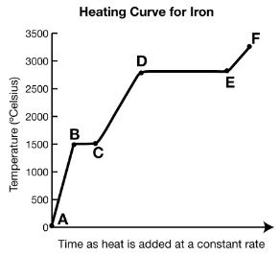
Answer questions 5 and 6 based on the information below.

Physical Constants for Iron
Specific Heat | 0.451 J/g K
Heat of Fusion | 272 J/g
Heat of Vaporization | 6120 J/g

5) Calculate the heat absorbed by 15.0 grams of iron during interval BC.

6) Calculate the heat absorbed by 15.0 grams of iron during interval DE.

