Name: _________________________________ Date: ____________

Vapor Pressure Curves
Directions: Examine the models given in each section and use them to answer the key questions that follow.

Model 1:
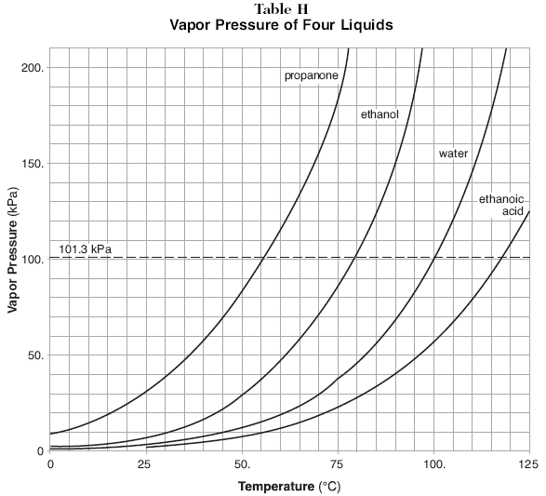
A liquid will boil when its vapor pressure equals atmospheric pressure. Water’s normal boiling point is 100°C. At this temperature the vapor pressure of the water is equal to 101.3 kPa, standard atmospheric pressure (see Model 1 graph). If we were in a location with a different atmospheric pressure the boiling point would be different. For example, if the atmospheric pressure were 90 kPa, the boiling point of water would be 95°C.

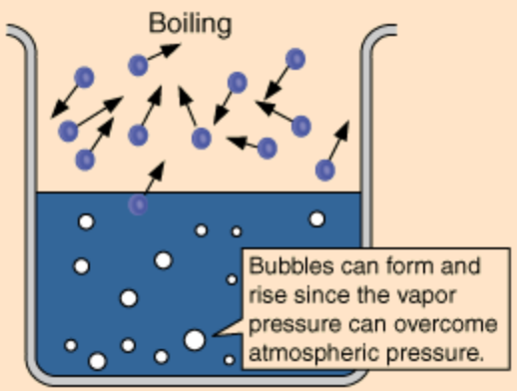

Key Questions:
1. a. Observe the vapor pressure curves for the four liquids in Model 1. What is plotted on the x-axis and what
is plotted on the y-axis?

b. What is the relationship between temperature and vapor pressure?

2. According to the information provided in Model 1, what determines the temperature at which a liquid boils?

3. a. What is the normal boiling point of water? How do you know?

b. Atmospheric pressure drops to approximately 34 kPa at the summit on Mount Everest (8,848 meters above sea level). At what temperature would water begin to boil at the summit? Why?

5. a. What is the normal boiling point of propanone? _____________
b. At what temperature will propanone boil if the atmospheric pressure is 70 kPa? _____________
Model 2:
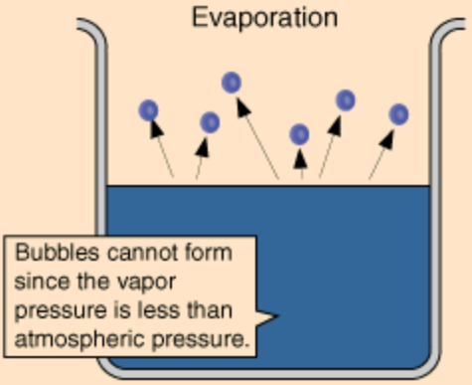
Evaporation, unlike vaporization, happens on the surface of liquids at all temperatures. This process is related to the strength of the forces holding the molecules in the liquid phase. The weaker the forces, the faster the molecules will escape from the liquid into the gas phase. A liquid with weak intermolecular forces will have a relatively large amount of vapor (gas phase) present above its surface.

Task: Place an equal amount of ethanol, propanone (acetone) and water on three separate cotton balls. Wipe the cotton balls on the desk at the same time. Observe the relative rate of evaporation for the liquids. Record your observations below.
Observations:

Key Questions:

1. Which liquid evaporated at the fastest rate? _____________________
2. Which liquid evaporated at the slowest rate? _____________________
3. Based on your observations, which liquid has the highest vapor pressure? Explain your answer.

4. Predict which of the three liquids used in this task would have the highest boiling point. Support your answer with an explanation.

5. Which of the three liquids has the strongest intermolecular forces of attraction? Support your answer with an explanation.

6. How do the intermolecular forces in propanone compare to the intermolecular forces found in water? Support your answer with an explanation.

Conclusions:

1. Compare and contrast evaporation and vaporization (boiling).

2. How does temperature affect the vapor pressure of a substance?

3. How do intermolecular forces affect the vapor pressure of a substance?

4. How are vapor pressure and boiling point related?

Applications:

1. A thermometer is placed in a beaker of water at room temperature. The beaker, water, and thermometer are covered by a bell jar attached to a vacuum pump. The pump is turned on and the pressure inside the bell jar is reduced. Predict what would be observed inside the bell jar.

2. Based on your predictions, suggest a possible boiling point for the water in the bell jar by using the information on the vapor pressure curve in Model 1. (Specify both temperature and pressure.)

3. Suggest a reason why changes need to be made in the cooking time when eggs are boiled in a location with a high altitude such as Denver, when compared to the cooking time at a sea level location such as Miami. Support your answer with insight you have gained from this activity.

