Recently, planetary geologists have been using spectroscopy to find evidence of past water on a planet’s surface, in particular Mars. Satellites orbiting Mars contain instruments that are able to zoom in on the planet’s surface to analyze features and determine the chemical composition of the surface. Scientists are able to use spectroscopy to analyze the light reflected off of the surface of Mars and are looking to identify minerals that formed in liquid water. The presence of silicates indicates the presence of water in the past. Spectra A, B and C below are samples of spectroscopy data collected by the Mars Global Surveyor. Identify the elements in spectra A, B and C by comparing the bright lines present with the lines in the spectra for known elements.

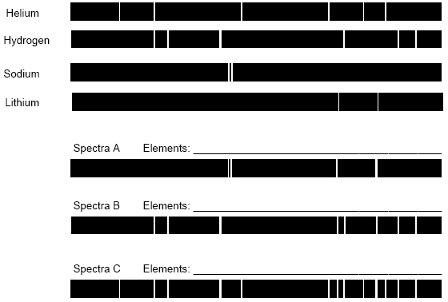
Spectra for
Known
Elements

Spectroscopy Data
collected by
Mars Global Surveyor

Analysis Questions:
1. How are spectral lines produced?

2. What does it mean that spectral lines of elements are like fingerprints?

3. Why are the spectral lines of different elements unique?

4. What are some practical applications for spectroscopy?

5. After identifying the elements present in Spectra A, B and C, what could you say about the chemical composition of the surface of Mars?

