EXTRA PRACTICE & ANSWER KEY

**KEEP SCROLLING DOWN TO SEE ANSWER KEY**

1) Determine the energy transformation that occurs in each example using the word bank: thermal, radiant, electrical, chemical, nuclear. (JUST TRY IT FOR FUN)

a) Pu atoms split in half and a nuclear bomb explodes. __________ __________

b) Methane gas reacts with oxygen and burns. __________ __________

c) A glass tube is plugged in and we see neon colors. __________ __________

2) What is the definition of heat and what unit do we use to measure heat?

3) What is the definition of temperature and what units do we use to measure temperature?

4) Convert the following temperatures: 30°C = ________ K

400 K = ________ °C

5) Name the following phase changes and determine if they are endothermic or exothermic.

CH₃OH(l) CH₃OH(g) _________________ Endothermic or Exothermic?

CO₂(s) CO₂(g) _________________ Endothermic or Exothermic?

H₂O(l) H₂O(s) _________________ Endothermic or Exothermic?

NaCl(s) NaCl(l) _________________ Endothermic or Exothermic?

N₂(g) N₂(l) _________________ Endothermic or Exothermic?

Answer questions 6-8 based on the heating curve of a substance below.
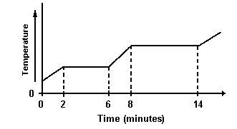
6) How much time passed between the first appearance of the liquid phase and the first appearance of the gas phase?

7) Describe the changes in KE and PE between minutes 8 and 14.

8) Draw a particle diagram representing the phase(s) present during minutes
8 and 14.

Answer questions 9-11 based on the heating curve of a substance below.
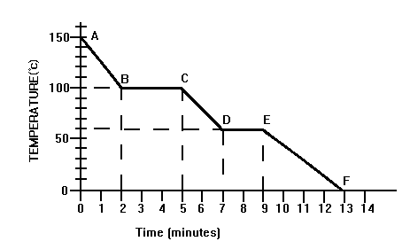

9) What is the freezing point of the substance?

10) During which segment do both the gas and liquid phase exist?

11) At what time do the particles in the substance have the most amount of energy?

ANSWER KEY

1) Determine the energy transformation that occurs in each example using the word bank: thermal, radiant, electrical, chemical, nuclear.

a) Pu atoms split in half and a nuclear bomb explodes. nuclear thermal or radiant

b) Methane gas reacts with oxygen and burns. chemical thermal or radiant

c) A glass tube is plugged in and we see neon colors. electrical thermal or radiant

2) What is the definition of heat and what unit do we use to measure heat?

The TOTAL kinetic energy of particles in a sample – measured in Joules (J).

3) What is the definition of temperature?

The AVERAGE kinetic energy of particles in a sample.

4) Convert the following temperatures: 30°C = 303 K

400 K = 127 °C

5) Name the following phase changes and determine if they are endothermic or exothermic.

CH₃OH(l) CH₃OH(g) vaporization/boiling Endothermic or Exothermic?

CO₂(s) CO₂(g) sublimation Endothermic or Exothermic?

H₂O(l) H₂O(s) freezing Endothermic or Exothermic?

NaCl(s) NaCl(l) melting Endothermic or Exothermic?

N₂(g) N₂(l) condensing Endothermic or Exothermic?

Answer questions 6-8 based on the heating curve of a substance below.
6) How much time passed between the first appearance of the liquid phase and the first appearance of the gas phase? 6 minutes (solid starts to melt at 2 min so that’s the first appearance of liquid, then the liquid begins to boil at 8 so that’s the first appearance of a gas).

7) Describe the changes in KE and PE between minutes 8 and 14.
KE remains constant and PE increases.

8) Draw a particle diagram representing the phase(s) present during minutes
8 and 14.
Both liquid and gas should be present.

Answer questions 9-11 based on the heating curve of a substance below.

9) What is the freezing point of the substance? 60°C

10) During which segment do both the gas and liquid phase exist? BC

11) At what time do the particles in the substance have the most amount of energy? 0 min

